Complexity Theory – Stacey diagram
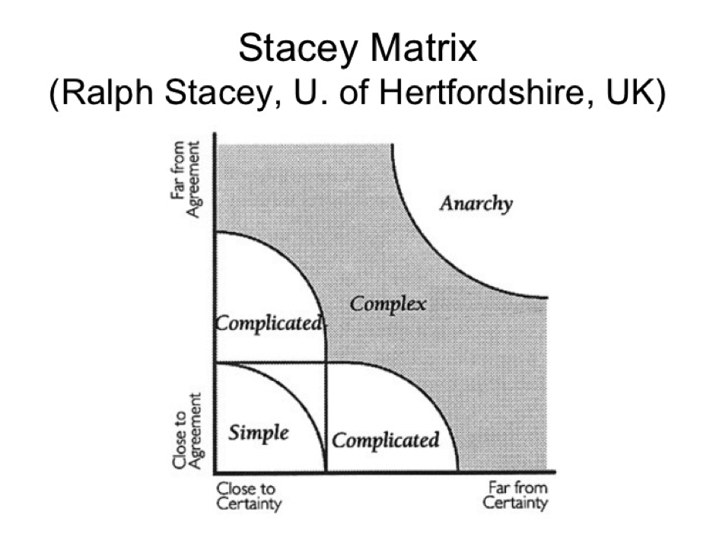
Watch this video…
https://youtu.be/10sTkUlylGI
- SIMPLE – technical rational decision making, evidence based, use data from past to predict the future, repeat what works well
- COMPLICATED – close to certainty, further from agreement – Political decision making – disagreement about which outcomes are desirable, need coalition building, negotiation and compromise
- COMPLICATED – close to agreement but further from certainty – Judgemental decision making – cause and effect linkages uncertain, gal is to head towards an agreed future state even though path cannot be predetermined
- CHAOS – very high levels of uncertainty and disagreement, traditional methods of planning, visioning and negotiation are insufficient
- COMPLEXITY – traditional management processes not very effective, zone of high creativity, innovation

DISCUSS
Examples for each region
Which approaches make most sense for which region and why?
What factors make an issue one area or another?
Look at current and future issues – Brexit, GP recruitment and retention,
Complexity theory is also useful when helping trainees understand how we deal with uncertainty.
The levels of agreement about what is done in GP is much less clear and often intimidating. For example the practice diabetes guideline (2008) is different from NICE (England) which is different from SIGN (Scotland) – Dr L gives drug A for X and Dr M give drug B and Dr L give no antibiotics on Mondays and everyone some on Fridays!
We need to be explicit with our trainees as they observe what we do and why we do it.
In discussion with trainees it is clear that the majority think their trainers are good GPs because they know lots and are usually very certain what to do. I.e. they work with a very large Area A.
But trainers know that most of the work we do is in Area B. (The complexity zone = the “swampland” of GP) Many of the things we deal with do not have a good evidence base to support clear agreement. But we have the capability of managing complex situations by developing shared agreement with patients and of knowing how to develop some certainty by discovery, discussion and safety netting. We usually become comfortable about it being ok for an individual patient to be managed outside the usual norms. And we know that sometimes chaos is the lot of certain patients.
In practical terms we know that many things influence how we manage individual patients and most protocols don’t allow for this.
The way to learn about managing the swampland is less about gaining knowledge and more by
- Experiential learning.
- Situational learning (shadowing, apprenticeship, rotational attachments)
- Small group learning (case based, role play, problem solving peer support)
- Problem based learning (how to find out, teamwork)
- Self Directed (reflective practice, using patients learning log, networking informally)
And how much fun is that
If you want more BMJ 2001;323;799-803 “Coping with Complexity and educating for Capability – Greenhaugh and BJGP January 2005 “Complex consultations and the edge of Chaos” Innes et al

