Circle of control
CIRCLE OF CONTROL – BE PROACTIVE

This is the ability to control one’s environment, rather than have it control you, as is so often the case. Self determination, choice, and the power to decide response to stimulus, conditions and circumstances
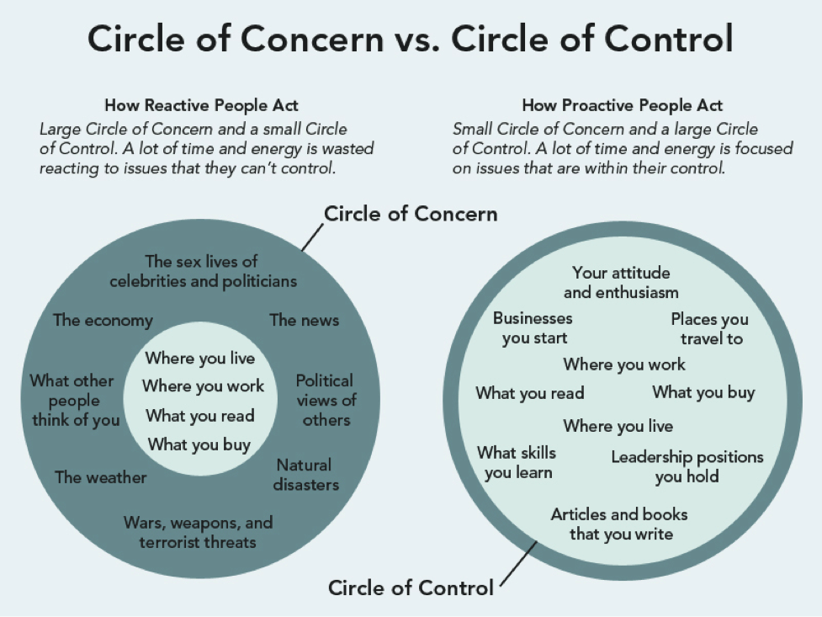

Exercise
Take a piece of paper and draw a line down the middle
On the left hand side write down the things you have complete control over
On the right hand side put everything else, things that are bothering you, weighing you down, etc
Discuss

