

The Scaling the Heights

New Trainers Workbook

27th January – 24th February 2015

How to be a Good
Educational Supervisor

Middleton Hall
Warwickshire B78 2AE




“Education is what survives when what has been learned has been forgotten”
BF Skinner


AIMS:
Course Aims and Objectives
To prepare new trainers for GP training to the current requirements in the UK
OBJECTIVES:
By the end of the course you will know:
- The current curriculum requirements for MRCGP
- How to train effectively within these requirements
- How to keep a learning portfolio for yourself
METHODS:
Over these 5 module days you will be in a collaborative learning group of 7
with two facilitators. The groups will run with adult self-directed learning principles
and an expectation that all participants will teach & learn with each other.
The GMC requirements for an Educational Supervisor relate to 7 areas drawn from
AoME Framework for the Professional Development of Postgraduate Medical Supervisors
1) ensuring safe and effective patient care through training
2) establishing and maintaining an environment for learning
3) teaching and facilitating learning
4) enhancing learning through assessment
5) supporting and monitoring educational process
6) guiding personal and professional development
7) continuing professional development (CPD) as an educator

We will cover these by using the 12 competencies of a GP trainee as our guide to the course.
ASSESSMENT:
You will successfully complete the course by:
- Attending all 5 days
- Engaging with the activities required
- Constructing & keeping a learning portfolio for the duration, to be reviewed by
the course facilitators and your colleagues on the course
- Providing evidence of reflection and insight into your development as a trainer
- Completing an online module in Equality & Diversity.

THE 12 COMPETENCIES OF A GP TRAINEE/TRAINER

RELATIONSHIPS:(3)
- Communication & consulting skills,
- Teaching holistically,
- Working with colleagues & in teams.

DIAGNOSTICS: (3)
- Educational data gathering,
- Teaching/ facilitating learning in others,
- Making an educational diagnosis and decisions.

MANAGEMENT: (3)
- Managing complex educational situations,
- Educational administration and IT,
- Community orientation.

PROFESSIONALISM: (3)
- Maintain your performance, ongoing teaching & learning skills,
- Maintaining an ethical approach,
- Maintaining your fitness to teach.
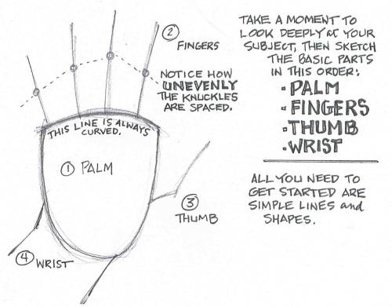

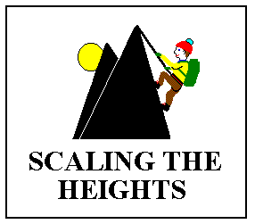
Introduction - and Ethos of the Scaling the Heights Group.
- We share the following values:
Learning and teaching are systemic systemicssystemic
- Learning involves the whole person, the social, the emotional, and the physical
as well as the cognitive. We aim to balance the scientific and reductionist basis
for teaching medicine by recognising the relationship between physical and mental
states in learning
Learning is personal

- We learn and teach in a variety of ways and there is no one right way to learn.
We explore a wide range of learning/teaching activities to achieve a flexible
response to the diversity of learning styles and contexts.
Learning is more effective when the learners are motivated intrinsically and are in control of their own learning

- We believe that even in training contexts where there is an ‘external’ agenda
it is possible to help learners harness their internal motivation to achieve these requirements. On Scaling the Heights courses we explore the processes
involved in sharing and transferring power and control from facilitator to learner.
Those who have considered their own development are better equipped to help others develop and implement change

- Within Scaling The Heights we set a premium on our own development as
educators and to this end we meet regularly to share teaching/learning
experiences and learn from one another.

Outline Programme: - (Varied according to group needs)
We have grouped the 12 Competencies of a GP into 4 days of the course, leaving the final day as assessment, review and round-up.
We start at 9am and aim to finish by 5pm each day
Session One Tuesday January 27th 2015
- Relationships

- Communication & consulting skills
- Teaching holistically
- Working with colleagues and in teams

Session Two Tuesday February 3rd
- Diagnostics

- Educational data gathering
- Teaching (facilitation of learning for others)
- Make an educational diagnosis and decisions

Session Three Tuesday February 10th
- Management

- Managing complex educational situations
- Educational administration and Information Technology
- Community orientation

Session Four Tuesday February 17th
- Professionalism

- Maintain your performance, ongoing learning & teaching skills
- Maintaining an ethical approach to training,
- Maintain your fitness to teach

Session Five Tuesday February 24th
- Assessment
- Feedback and Evaluation

In between the scheduled 5 days of the course you will be required to do some ‘homework’ for your portfolio. This becomes part of the evidence of satisfactory completion of the course.

Who’s who.
Who’s Who?

Course Facilitators
- Michael Dawson michaeljdawson@doctors.org.uk
- Mike Deighan mikedeighan@btinternet.com
- Bill Foster fosterbill@btinternet.com
- Kevin Ilsley kevinilsley@btinternet.com
- Bitty Muller bitty.muller@btinternet.com
- Shake Seigel shake.seigel@btinternet.com

Course Participants & Groups

Please see separate sheet for the up-to-date list and groupings



SMALL GROUP INTRODUCTIONS

Introductions help us to feel at ease in the group so that we can then contribute to the group’s discussions and activities and also help each other do likewise.
The Interview Questions below are designed to facilitate disclosure at different levels, promote positive relationships within the group and help create a climate conducive for learning.

- In pairs interview each other for 7 minutes each, using all or some of the questions below. Feel free to choose how you use them and allow your partner complete freedom in how he or she chooses to respond.
- At the end of the interview, check which of your partner’s responses he/she is happy to share with the group.
- When the interviews are complete you will have one minute to introduce your partner to the group. Your partner can then say a something about their brought object before introducing you to the group. You will then have an opportunity to talk about your own brought object.
- Before starting this exercise consider how you feel about the group and how ready and willing you are to work and learn together. At the end reflect on how these feelings and readiness have changed.
- Before beginning, your group facilitator will raise the concept of “ group rules”

Interview Questions:
- Tell me about a WHERE – a PLACE that has special significance to you.

- Tell me about a WHAT – something important or useful that you DO or HAVE DONE.

- Tell me about a HOW – a SKILL or ABILITY that you are proud to possess.

- Tell me about a WHY - tell me why you do an ACTIVITY that is important to you.

- Tell me about a WHO – tell me SOMETHING CENTRAL ABOUT YOURSELF: something that makes you who you are. And then think about what you might say to the group regarding the object you have brought with you, and why you chose it.
Trainer Competencies
[As used on the Scottish Prospective Educational Supervisors’ Course]
1 | Communication and consultation skills
This competency is about the Trainer’s communication (with patients, the Primary Health Care Team and the learner) and the use of recognised consultation techniques with patients.
2 | Teaching holistically
This competency is about the ability of the Trainer to operate in physical, psychological, socio-economic and cultural dimensions, taking into account feelings as well as thoughts.
3 | Working with Colleagues and in Teams
This competency is about working effectively with other Primary Health Care Team (PHCT) members to deliver a multi- professional training environment for the learner.
4 | Educational Data Gathering and Interpretation
This competency is about the gathering and use of data/information for the purpose of educational needs assessment. It involves ability to choose and employ appropriate assessment tools and to interpret their findings.
5 | Making an Educational Diagnosis and Making Decisions
This competency is about having a conscious structured approach to diagnosing educational problems/issues and working with the learner to develop a clear and appropriate educational plan.
6 | Teaching (Facilitation of Learning in Others)
This competency is about facilitating learning in others, recognising differences between learners and the corresponding different methods of teaching.
7 | Managing Complex Educational Situations
This competency is about the ability to manage complex educational situations, e.g., illness, disability, distress and attitudinal problems in the learner. It encompasses the difficulty of working with sub-optimal resources & time pressures.
8 | Educational Administration and Information Technology
This competency is about the appropriate use of educational administration systems, effective record keeping and information technology, for the benefit of the learner and the Deanery.
9 | Community Orientation
This competency is about the influence of the local community and geographical area on learning.
10 | Maintaining performance in learning and teaching
This competency is about the Trainer maintaining performance and effective continuing professional development.
11 | Maintaining an ethical approach to Teaching
This competency is about practicing ethically with integrity and a respect for diversity. This includes treating the learner with proper respect and giving them proper autonomy
12 | Fitness to Teach
This competency is about the Trainer’s awareness of how their own performance, conduct or health affects the relationship with the learner

This page is a divider page – maybe with Day 1 on the tab

Day 1 - Relationships.

“If you can learn from hard knocks you can also learn from soft touches.” Carolyn Kenmore.

Communication and consultation skills
This competence is about the Trainer’s communication (with patients, the Primary Health Care Team and the learner) and the use of recognised consultation techniques with patients.

Teaching holistically
This competence is about the ability of the Trainer to operate in physical, psychological, socio-economic and cultural dimensions, taking into account feelings as well as thoughts.

Working with Colleagues and in Teams
This competency is about working effectively with other Primary Health Care Team (PHCT) members to deliver a multi- professional training environment for the learner.



Trainer Competencies
Details

1 | Communication and consultation skills
This competence is about the Trainer’s communication (with patients, the Primary Health Care Team and the learner) and the use of recognised consultation techniques with patients.
Specific competences might be (in no particular order)
- Ability to communicate effectively with a range of different people
- Ability to vary communication style dependent on need
- Ability to give specific descriptive feedback with suggested options for change
- Demonstrates competence in the consultation

Insufficient Evidence  From the available evidence, the doctor’s performance cannot be placed on a higher point of this developmental scale. |  | Needs Further Development  Is able to talk easily to other people. | Competent  Is able to use a limited range of communication skills, and has some ability to vary them. |  | Excellent  Is accomplished at using a range of communication skills, including information-giving, conversation, empathy, confrontation and challenge.
 |  | Develops a working but superficial relationship with the learner and other colleagues. Generates no complaints. | Has a comfortable and easy relationship with learners and work colleagues, and is seen to be approachable. |  | Uses communication to develop effective and deep relations with work colleagues and learners.
 |  | Is able to give feedback to the learner in descriptive language | Provides feedback that is descriptive, incorporates suggestions for change and produces little emotional damage. |  | Demonstrates mastery of feedback that is both sensitive to the learner’s needs and sufficiently challenging to effect change.
 |  | In the consultation, develops a working relationship with the patient, but one in which the problem rather than the person is the focus. | Explores the patient’s agenda, health beliefs and preferences. |  | Incorporates the patient’s perspective and context when negotiating the management plan.
 |  | Produces management plans with patients that are appropriate to the presenting problem. | Works in partnership with the patient, negotiating a mutually acceptable plan that respects the patient’s agenda and preference for involvement. |  | Whenever possible, adopts plans that respect the patient’s autonomy.
 |  | Provides explanations that are relevant and understandable to the patient, using appropriate language. | Explores the patient’s understanding of what has taken place. | Uses a variety of communication techniques and materials to adapt explanations to the needs of the patient.
 |  | Achieves the tasks of the consultation but uses a rigid approach. | Flexibly and efficiently achieves consultation tasks, responding to the consultation preferences of the patient. | Appropriately uses advanced consultation skills such as confrontation or catharsis to achieve better patient outcomes.

Methods of Assessment (of Communication and consultation skills)
Possible “tools” to assess these in a prospective trainer
- Peer Review of a video of consultations from a “typical” surgery
- Patient Satisfaction Questionnaire
- Multi-Source Feedback
- Demonstrating the use of Consultation Observation Tool in small group
- Role play in small group
- Discussion in small group
- Demonstrates knowledge of different consultation models


2 | Teaching holistically
This competence is about the ability of the Trainer to operate in physical, psychological, socio-economic and cultural dimensions, taking into account feelings as well as thoughts.
Specific competences might be (in no particular order)
- Demonstrates awareness of social and cultural background and its relationship with learning
- Manages demands on own time and emotions
- Utilises teaching resource of PHCT and others appropriately
- Takes account of learners feelings and thoughts in addition to actions
- Can identify the registrar who is having problems not confined to academic or workplace and help manage the problem

Insufficient Evidence  From the available evidence, the doctor’s performance cannot be placed on a higher point of this developmental scale. |  | Needs Further Development  Enquires into learner’s background. | Competent  Demonstrates understanding of the learner in relation to their social and cultural background. | Excellent  Uses this understanding to inform discussion and to generate practical suggestions for educational development
 |  | Recognises the impact of external influences in learner’s clinical performance | Additionally, recognises the impact on learning | Recognises and shows understanding of the limits of the trainers ability to intervene in the holistic and pastoral care of the learner
 |  | Uses him/herself as the sole means of supporting the learner. | Utilises appropriate support (including primary health care team members, associate advisers and trainer colleagues) targeted to the needs of the learner. | Facilitates learner to organise appropriate support systems for themselves and monitors overall well being
 |  | Aware of beliefs and values of trainees | Explores higher level emotions with learners | Facilitates learner to be aware of and use emotions in patient and peer interactions.

2 | Teaching holistically
Methods of Assessment
Possible “tools” to assess these in a prospective trainer
- Kiddi ring
- Multi Source Feedback
- Role play
- Details of Practice meetings
- “Arts in Medicine”
- Logical levels introductions/ problem solving
- Development of an introductory conversation/ relationship building tool to use with trainees
- Demonstration of cultural awareness in group discussion, reflection



3 | Working with Colleagues and in Teams
This competency is about working effectively with other Primary Health Care Team (PHCT) members to deliver a multi- professional training environment for the learner.
Specific competences might be (in no particular order)
- Ability to demonstrate team working in a professional environment.
- Ability to understand and value the roles and responsibilities of other PHCT members.
- Ability to develop an induction program for the learner into the practice to allow exposure to the roles of other PHCT members.
- Ability to motivate and involve PHCT members in formal and informal teaching and feedback with the learner.
- Ability to provide educational leadership skills
- Developing a reliable and safe environment for feedback on a learner’s progress and team working capabilities.
- Ability to co-ordinate and feedback developmental information from PHCT members to the learner in a constructive fashion.

Insufficient Evidence  From the available evidence, the doctor’s performance cannot be placed on a higher point of this developmental scale. |  | Needs Further Development  Aware of different roles of other PHCT members | Competent  Can involve other members of the PHCT in design and implementation of induction programme | Excellent  Motivates other members of the PHCT to take initiative in design and implementation of induction programme
 |  | Introduces learner to other members of the PHCT, and ensures involvement in PHCT meetings | Encourages learner and PHCT members to develop their own educational relationship | Empowers and encourages learner to proactively learn from and relate to other members of the PHCT
 |  | Shares educational ideas, challenges and successes with other members of the PHCT | Able to teach other members of the PHCT to enhance their own skills in teaching | Devolves educational planning and leadership to other members of the PHCT
 |  | Discusses learner’s strengths and weaknesses with other members of the PHCT | Actively seeks coordinated and structured feedback from the members of the PHCT on the learner’s progress. | Collaborates with other members of the PHCT to develop evaluation and feedback on the learner’s progress.

3 | Working with Colleagues and in Teams
Methods of Assessment
Possible “tools” to assess these in a prospective trainer
- Significant Event Analysis
- Multi-source feedback review
- Role-play
- Small group discussion
- Induction pack / programme development including PCHT members

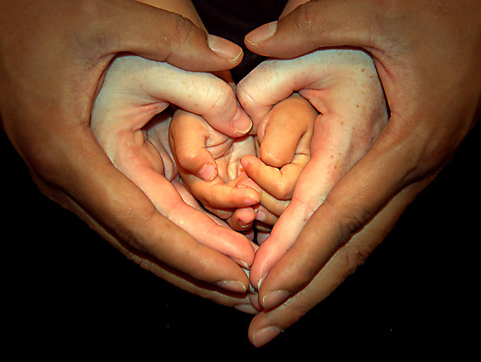

This page is a divider page –with Day 2 on the tab
.
Day Two - Diagnostics

“The most important single factor influencing learning is what the learner already knows. Ascertain this and teach accordingly” - Ausubel

Educational Data Gathering and Interpretation
This competence is about the gathering and use of data/information for the purpose of educational needs assessment. It involves ability to choose and employ appropriate assessment tools and to interpret their findings.

Making an Educational Diagnosis and Making Decisions
This competence is about having a conscious structured approach to diagnosing educational problems/issues and working with the learner to develop a clear and appropriate educational plan.

Teaching (Facilitation of Learning in Others)
This competence is about facilitating learning in others, recognising differences between learners and the corresponding different methods of teaching.



4 | Educational Data Gathering and Interpretation
This competence is about the gathering and use of data/information for the purpose of educational needs assessment. It involves ability to choose and employ appropriate assessment tools and to interpret their findings.
Specific competences might be (in no particular order)
- Knowledge of wide range of needs assessment tools.
- Ability to employ appropriate tools at correct stage in learner’s development.
- Ability to interpret results and share these with the learner.
- Ability to give feedback on progress/performance.
- Knowledge and ability to use e-portfolio.

Insufficient Evidence  From the available evidence, the doctor’s performance cannot be placed on a higher point of this developmental scale. |  | Needs Further Development  Knows about needs assessment tools | Competent  Ability to use a range of needs assessment tools | Excellent  Able to develop and modify assessment tools to meet the needs of a particular learner.
 |  | Able to interpret the results of simple assessment tools | Able to integrate the results of a range of needs assessments and incorporate into a combined summary. | Works with learner to interpret and add meaning to results of an integrated needs assessment summary.
 |  | Understands principles of feedback | Able to use feedback appropriately in an educational setting | Encourages two-way feedback and appraisal with learner throughout educational programme.
 |  | Able to use e-portfolio when shown | Regularly updates and browses learner’s e-portfolio | Facilitates learner’s fullest use of e-portfolio throughout educational programme.


4 | Educational Data Gathering and Interpretation
Methods of Assessment
Possible “tools” to assess these in a prospective trainer
- Video of needs assessment “debrief” with learner
- Demonstration of knowledge of at least one needs assessment tool
- Role play of mock scenario
- Small group discussion on needs assessment tools – e.g. advantages and disadvantages of each.
- Demonstrates feedback in role play using a recognised feedback method (e.g. Pendleton, SET GO)

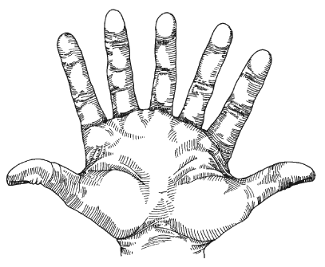

5 | Making an Educational Diagnosis and Making Decisions
This competence is about having a conscious structured approach to diagnosing educational problems/issues and working with the learner to develop a clear and appropriate educational plan.
Specific competences might be (in no particular order)
- Ability to interpret and integrate a variety of information sources about a learner, including learning styles.
- Ability to detect educational problems early and take appropriate action.
- Assess learners ability to direct their own learning
- Ability to feedback and appraise learner’s progress
- Ability to formulate jointly with the learner an appropriate educational plan for progress through each phase of training.
Insufficient Evidence  From the available evidence, the doctor’s performance cannot be placed on a higher point of this developmental scale. |  | Needs Further Development  Collects the results of a range of needs assessment tools together | Competent  Able to integrate and cross-reference the results of a range of needs assessments, and incorporate into a combined summary | Excellent  Works with learner to interpret and add meaning to results of an integrated needs assessment summary.
 |  | Has theoretical understanding of the sorts of problems that learners can present | Able to identify and respond appropriately to problems arising during both the training period and an educational session | Proactively seeks out and responds to educational and relationship problems that may arise in the learner.
 |  | Aware of learner’s capacity to self-direct | Able to identify and work with the learner’s self-motivation and capacity for self-directedness | Proactively responds to learner’s level of self-directedness and seeks to enhance it.
 |  | Knowledge of principles of feedback. Has simple feedback skills. | Can constructively and appropriately feedback to learner both positively and when there is room for improvement | Enhances learner’s own self-criticism and self-awareness.
 |  | Knowledge of educational planning principles and key milestones in educational progress | Able to work with learner to develop, carry out and monitor an appropriate educational plan, based on identified needs | Empowers and encourages learner to develop an educational plan based on their own identified needs.

5 | Making an Educational Diagnosis and Making Decisions
Methods of Assessment
Possible “tools” to assess these in a prospective trainer
- Video of interim review or appraisal
- Video of a tutorial
- Role play of an educational problem scenario
- Trainer’s portfolio or educational diary
- Review of educational needs assessments and educational plans developed by the Trainer
- Feedback skills role play
- Knowledge of COT, CBD, mini-CEX, CSR & ESR assessments & demonstration of their use.



6 | Teaching (Facilitation of Learning in Others)
This competence is about facilitating learning in others, recognising differences between learners and the corresponding different methods of teaching.
Specific competences might be (in no particular order)
- Ability to formulate a range of educational solutions to meet the learning needs of a learner
- Ability to apply the most appropriate of those solutions to meet the educational needs presented by each individual learner.
- Ability to recognise the learner with problems and work with them toward a resolution
- Skilled in a variety of teaching methods (eg tutorial, 1:1, seminar, mini-lecture, etc)
- Ability to develop new and enhanced teaching skills
- Knowledgeable of theoretical basis of learning and teaching
- Assess learners ability to direct their own learning

Insufficient Evidence  From the available evidence, the doctor’s performance cannot be placed on a higher point of this developmental scale. |  | Needs Further Development  Uses one or two educational methods to teach learner | Competent  Is competent in a range of educational methods | Excellent  Develops new educational methods when need arises
 |  | Uses appropriate but limited educational interventions with little flexibility or consideration of preferences of learners. | Varies educational options responsively according to the learning styles, needs and preferences of learners. | Initiates and offers innovative approaches to education to deal with specific learner needs
 |  | Recognises the presentation of common problems met by learners. | Develops plans when problems encountered | Anticipates and works to avoid problems occurring. Works with learner to overcome their own problems
 |  | Responds to problems by routinely suggesting intervention. | Acts as a resource and provides variety of solutions. | Facilitates learner to solve their own problems
 |  | Recognises importance of learner’s self direction. | Routinely checks and encourages learner’s level of self direction | Empowers learner to be self-directed
 |  | Performs up to, but does not exceed, the limits of their own competence. | Willing to challenge own abilities and set higher goals | Skilled at developing new resources when needed.
 |  | Responds skilfully to learners routine needs | Manages complex challenges with support | Able to respond appropriately to complex educational challenges not previously encountered.

6 | Teaching (Facilitation of Learning in Others)
Methods of Assessment
Possible “tools” to assess these in a prospective trainer
- Awareness of learning styles
- Mini teaching session / tutorial plan
- Curriculum based teaching session
- List of teaching methods
- Video of tutorial
- Case discussion
- Scenarios and role play
- Significant Event Analysis
- Reflective diary or portfolio
- Feedback from learner, or Multi-Source Feedback



This page is a divider page –with Day 3 on the tab

Day Three – Management.

“Managers do things right, whereas leaders do the right things” – Warren Bennis

Managing Complex Educational Situations
This competence is about the ability to manage complex educational situations, such as illness, disability, psychological distress and attitudinal problems in the learner, and encompassing the difficulty of working with sub-optimal resources and time pressures.

Educational Administration and Information Technology
This competency is about the appropriate use of educational administration systems, effective record keeping and information technology, for the benefit of the learner and the Deanery.

Community Orientation
This competency is about the influence of the local community and geographical area on learning.



7 | Managing Complex Educational Situations
This competence is about the ability to manage complex educational situations, such as illness, disability, psychological distress and attitudinal problems in the learner, and encompassing the difficulty of working with sub-optimal resources and time pressures.
Specific competences might be (in no particular order)
- Ability to recognise the range of educational complexity that can be presented by learners
- Ability to generate methods of management to address these complex learning situations
- Ability to deal with uncertainty by searching for information and evidence
- Ability to quantify risk in verbal, numerical and pictorial ways.

Insufficient Evidence  From the available evidence, the doctor’s performance cannot be placed on a higher point of this developmental scale. |  | Needs Further Development  Is aware of the range of complex problems dealt with by a Teacher in General Practice, particularly relating to multiple issues with one particular learner | Competent  Skilled at recognising multiple educational issues and problems generated by learners | Excellent  Pro-actively seeks to identify and explore multiple problems and educational “co-morbidity” in the learner.
 |  | Responds appropriately to the educational complexity when encountered | Is able to generate a range of management options for the complex educational problems presented by learners | Innovative at developing individual responses to a wide range of complex educational problems, particularly recognising constraints of time and resource
 |  | Recognises the uncertainty of educational diagnosis, and the use of time to resolve issues. | Able to discuss with learner issues of uncertainty.  Is aware that uncertainty can cause difficulties for learners.  Can recognise and manage distress in a learner | Skilled at working with learners to empower them to resolve issues of uncertainty, distress and educational “co-morbidity”.
 |  | Recognises that educational risk assessment is an integral part of managing educational complexity | Works with learner to help them identify the risks inherent in an educational situation. | Empowers learner to take responsibility for risk assessment and management.  Develops educational risk management strategies with other members of team

7 | Managing Complex Educational Situations
Methods of Assessment
Possible “tools” to assess these in a prospective trainer
- Case Discussion
- Scenarios and role play in group
- Awareness of some tools to diagnose educational problems
- Video of tutorials, or practice based meetings
- Demonstration of risk assessment strategies and protocols
- Awareness of whom to approach when issues arise

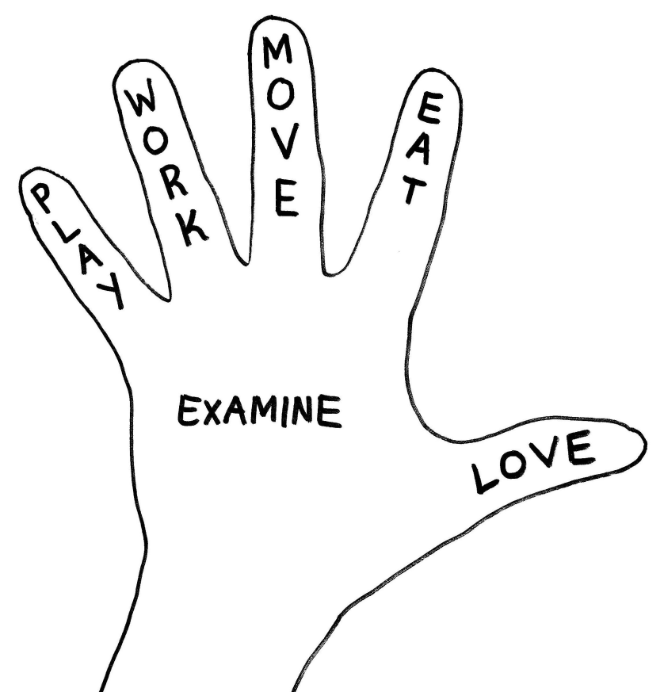

8 | Educational Administration and Information Technology
This competency is about the appropriate use of educational administration systems, effective record keeping and information technology, for the benefit of the learner and the Deanery.
Insufficient Evidence  From the available evidence, the doctor’s performance cannot be placed on a higher point of this developmental scale. |  | Needs Further Development  Demonstrates an understanding of the organisation of GP Specialist Training, the RCGP and local Deanery structures | Competent  Able to use the available organisational channels within the practice and the Deanery to facilitate and improve aspects of education and primary care administration within the practice. | Excellent  Uses and modifies organisational and IMT systems locally to facilitate:  - Enhanced training of the GP Trainee  - Educational governance  - Development of local educational initiatives
 |  | Uses a computer to enter aspects of the Trainee’s assessments on the e-portfolio. | Uses IT systems for a limited range of functions such as  Send and receive emails | Is accomplished at using IT systems in order to:  - Search the internet to answer educational and medical questions.  - Create letters, spreadsheets and PowerPoint presentations  - Embed within documents
 |  | Keeps a record of the tutorials and teaching given in the practice | Is prompt in keeping an educational record of the  - teaching in the practice  - the learner’s educational needs  - problems and issues | Develops a comprehensive record of learning and teaching, in collaboration with the learner and the other members of the PHCT involved in teaching.

8 | Educational Administration and Information Technology
Methods of Assessment
Possible “tools” to assess these in a prospective trainer
- Small group discussion
- Use of email between Units to other group members and Facilitator
- Use of Dropbox or similar to share documents and work-in-progress
- Demonstration of personally developed documents, presentations, etc
- Demonstration of use of internet resources to aid learning
- Demonstration of awareness of trainee e-portfolio and trainer’s role as educational supervisor
- Demonstration of practice educational records to the small group

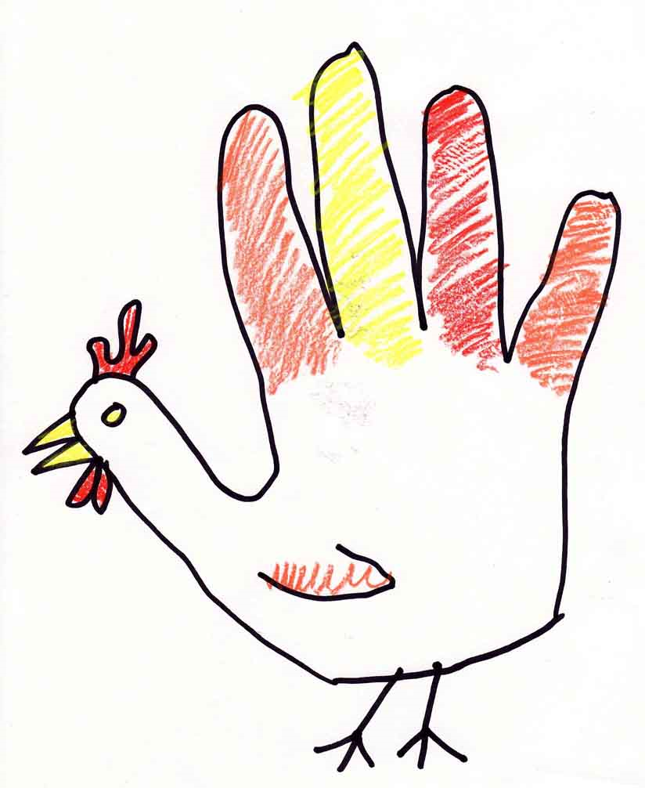

9 | Community Orientation
This competency is about the influence of the local community and geographical area on learning.
Specific competences might be (in no particular order)
- Ability to recognise and develop GP practice culture with respect to learning and teaching
- Ability to recognise and embrace cultural components of healthcare and learning in the local community
- Ability to use finite educational resources creatively

Insufficient Evidence  From the available evidence, the doctor’s performance cannot be placed on a higher point of this developmental scale. |  | Needs Further Development  Recognises the impact of GP practice culture on the learner | Competent  Applies an understanding of this culture to improve the educational experience for the GP Trainee | Excellent  Modifies the practice culture to enhance the teaching and learning that occurs within it.
 |  | Recognises that local cultural diversity impacts on the learning experience of the Trainee | Utilises the positive aspects of cultural diversity to enhance the Trainee’s learning | Works with diverse aspects of the local community to provide resource and teaching for the Trainee.
 |  | Recognises the range of educational resources, including money, and that they are limited | Demonstrates creativity in the use of educational resources for the benefit of the Trainee | Modifies & creates new educational resources for use in GP training.



9 | Community Orientation
Methods of Assessment (of Community Orientation)
Possible “tools” to assess these in a prospective trainer
- Utilises local community in training structures
- Can show how practice is prepared for GP training
- Induction materials/ handbook for GP trainee
- Encourages attendance at multidisciplinary team meetings
- Demonstrates cultural sensitivity / awareness
- Small group discussion
- Multi-source feedback

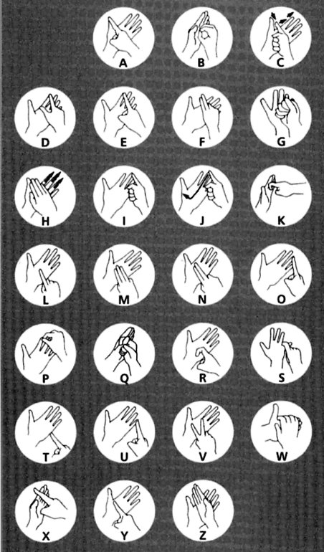

Subject divider page here – heading Day Four

Day Four - Professionalism

“Being a professional is doing the things you love to do, on the days you don't feel like doing them.” Julius Irving

Maintaining performance, learning and teaching
This competency is about the Trainer maintaining performance and effective continuing professional development (with respect to learning and teaching).

Maintaining an ethical approach to Teaching
This competency is about practicing ethically with integrity and a respect for diversity. This includes treating the learner with proper respect and giving them proper autonomy

Fitness to Teach
This competency is about the Trainer’s awareness of how their own performance, conduct or health affects the relationship with the learner



10 | Maintaining performance, learning and teaching
This competency is about the Trainer maintaining performance and effective continuing professional development (with respect to learning and teaching).
Specific competences might be (in no particular order)

- Values their own personal development
- Ability to self-motivate and commit to principles of life-long learning
- Ability to identify own strengths and weaknesses, and hence learning needs, with respect to the teaching role
- Ability to generate a learning plan to address identified learning needs
- Knowledgeable about and able to use a variety of ways of assessing teaching ability

Insufficient Evidence  From the available evidence, the doctor’s performance cannot be placed on a higher point of this developmental scale. |  | Needs Further Development  Is aware of the body of available educational literature, including educational theory, educational psychology and research findings. | Competent  Judges the weight of educational evidence, using critical appraisal skills and an understanding of basic statistical terms, to inform teaching. | Excellent  Is able to develop an individual response to the educational literature.  Moves beyond the use of existing evidence toward initiating and collaborating in educational research that informs educational practice.
 |  | Routinely engages in study to keep abreast of evolving educational practice and new developments. | Shows a commitment to educational development through reflection on teaching and the identification of and attention to learning needs.  Evaluates the process of learning so as to make future learning cycles more effective. | Systematically evaluates educational performance against external standards, using this information to inform peer discussion.  Demonstrates how elements of personal teacher development are related to the needs of the Deanery.
 |  | Recognises the importance and practice of educational audit and significant event analysis.  Recognises situations, e.g. through risk assessment, where the learner could be compromised. | Participates in educational audit where appropriate and uses this activity to evaluate and suggest improvements in personal and practice educational performance.  Engages in educational significant event reviews and learns from them as a team-based exercise. | Takes on a responsibility to develop the educational expertise and skills of the Primary Health Care Team.  Initiates quality assurance activity and actively follows up and acts on results
 |  | Contributes to the education of learners and colleagues.  Uses an annual appraisal to demonstrate quality of teaching. | Identifies own learning objectives with respect to teaching and learning. Has comprehensive learning plan and uses a variety of tools and educational methods to achieve it. | Evaluates outcomes of teaching, seeking feedback on performance.  Takes part in co-mentoring or small group learning sessions



10 | Maintaining performance, learning and teaching
Methods of Assessment (of Maintaining performance, learning and teaching)
Possible “tools” to assess these in a prospective trainer
- Small group discussion
- Demonstration of personal educational audits and SEAs.
- Presentation of recent developments in educational practice
- Minutes of practice educational meetings
- Appraisal paperwork relating to Teaching
- Reflective diary or portfolio
- Use of SMART to develop PDP for trainer role
- Awareness of trainer’s workshops



11 | Maintaining an ethical approach to Teaching
This competency is about practicing ethically with integrity and a respect for diversity.
This includes treating the learner with proper respect and giving them proper autonomy
Specific competences might be (in no particular order)
- Understanding of basic ethics and the broader perspectives that influence practice, including society and the community
- Recognition that teaching is an ethical activity with consequent benefits and also potential for harm.
- Ability to use cases and an ethical decision making model or grid to look at problems in a structured way
- Is aware of the importance of values and beliefs and respects the learner’s autonomy

Insufficient Evidence  From the available evidence, the doctor’s performance cannot be placed on a higher point of this developmental scale. |  | Needs Further Development  Has an understanding of basic ethics and the common issues that cause dilemmas in practice | Competent  Uses the principles of ethics to resolve the wide range of issues in practice in a structured way with learners | Excellent  Actively explores with the learner a structured ethical response to the dilemmas and conflicts implicit in patient care and the educational transaction.
 |  | Recognises the ethical implications of teaching | Actively explores with the learner the ethical implications of learning and teaching. | Empowers the learner to identify and resolve ethical dilemmas in the educational transaction.
 |  | Recognises that learners are different and does not discriminate against them because of those differences. | Recognises and takes action to address prejudice, oppression and unfair discrimination within self, other individuals and within systems | Actively promotes equality of opportunity for learners to maximise career prospects, and for individuals to achieve their full potential.
 |  | Is aware of the required professional values of a doctor and that these values might vary. | Is able to use an educational model that respects the learner’s autonomy but ensures that this is just part of any decisions that are made. | Can use a detailed understanding of ethical decision making to help developing the learner’s skills whilst also being able to assess their progress.

11 | Maintaining an ethical approach to Teaching
Methods of Assessment
Possible “tools” to assess these in a prospective trainer
- Video of tutorial
- Case discussion
- MSF
- Ethical grid (Seedhouse)
- Ethical decision making model (Molyneux)
- Scenarios & role play

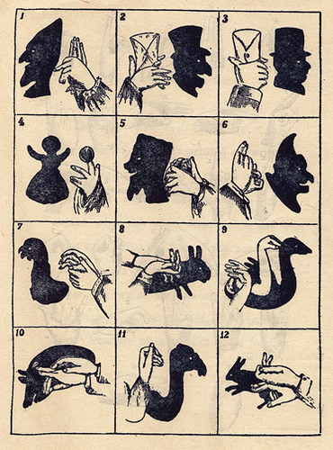
12 | Fitness to Teach
This competency is about the Trainer’s awareness of how their own performance, conduct or health affects the relationship with the learner
Specific competences might be (in no particular order)
- Recognition that emotional and physical health affects the ability to teach.
- Ability to identify poor personal educational performance and to take appropriate action

Insufficient Evidence  From the available evidence, the doctor’s performance cannot be placed on a higher point of this developmental scale. |  | Needs Further Development  Recognises that health and well-being affect the ability to teach | Competent  Proactive in taking steps to maintain personal health. | Excellent  Constructively uses health and well-being to enhance the relationship with the Trainee.
 |  | Attends to educational demands whilst showing awareness of the importance of addressing personal needs. | Achieves a balance between educational and personal demands that protects professional obligations and preserves health. | Anticipates situations that might damage the work/life balance and seeks to minimise the adverse effects.



12 | Fitness to Teach
Methods of Assessment
Possible “tools” to assess these in a prospective trainer
- Small group discussion
- Multi-source feedback
- Personal statement



Divider here – labelled Day 5

Day 5 – Evaluation, Reflection, Review

“Not everything that counts can be counted, and not everything that can be counted counts” Albert Einstein

Course review
Evaluation & Assessment
‘Wild card’ options
Final questions
Individual reviews of portfolio and progress with facilitators

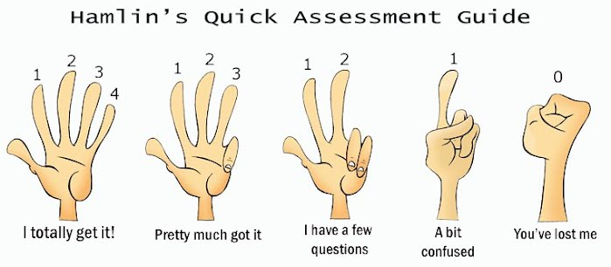



Divider page – Grid of evidence.

After this page insert the grid of evidence in landscape orientation
– provided separately

http://www.medicaleducators.org/aome/assets/File/AOME%20Essential%20User%20Guide%20Nov%202013.pdf

