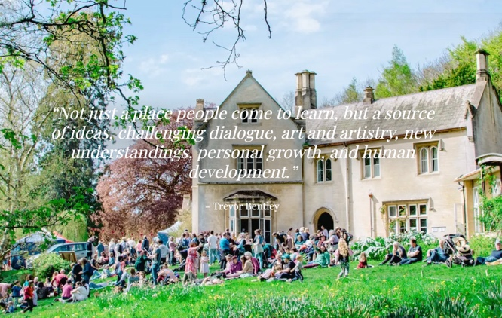  A collaborative learning event for established educators in primary care and beyond  Thursday 4th and Friday 5th June  Hawkwood Centre for Future Thinking | Hawkwood College, Stroud  https://www.hawkwoodcollege.co.uk/  Course Fee: £400 (including meals)  Accommodation costs: £100 per night* (B&B)  Some rooms available for the night of Wednesday 3rd  To book  Scaling the Heights – Unconference for Experienced Educators 2026: Booking Form – Fill in form  Queries to  scalingtheheights2026@gmail.com  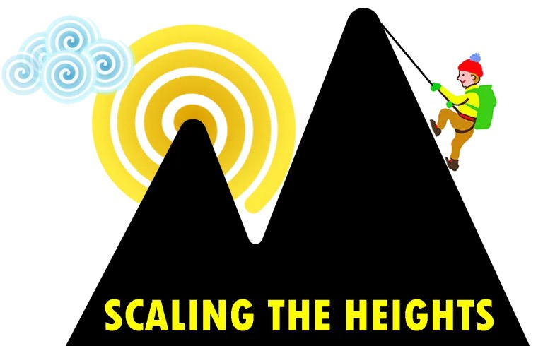 | Who is this for?  Established educators (TPDs, Trainers and others in General Practice and secondary care education We welcome participants from any professional background  Why ‘unconference’?  This learning event is collaborative and participant driven, following the needs of the group whilst using collective resources.  What is Scaling the Heights?- a group of like minded medical educators. See https://scalingtheheights.com/about/  What Happens?  Small groups working, sharing, and learning together over two days, using the extensive grounds for walking and learning.  Why should I come?  You will expand your skills, make new friends, increase your confidence in teaching and have a great two days in beautiful Gloucestershire countryside.
SCALING THE HEIGHTS UNCONFERENCE 2026

